RUSSIAN ACADEMY OF SCIENCES
faso OF rUSSIA
NATIONAL ACADEMY OF SCIENCES
OF THE KYRGYZ REPUBLIC

INFLUENCE OF EXTERNAL FIELDS
ON SEISMIC REGIME AND MONITORING OF THEIR MANIFESTATIONS
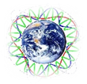

International Jubilee Conference, dedicated to 40th Anniversary from the foundation of Research Station RAS in Bishkek city

FIRST CIRCULAR

3 – 7 July 2018
Bishkek city, Kyrgyz Republic

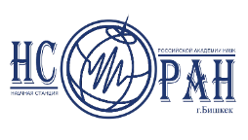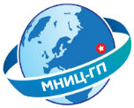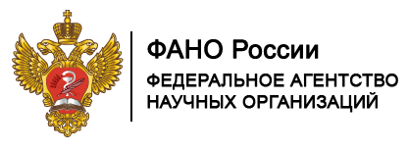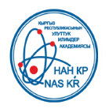
Organizers of the Conference:
- Department of the Earth’s Sciences, RAS
- Research Station RAS in Bishkek (RS RAS), KR
- International Research Center – Geodynamic Proving Ground in Bishkek (IRC-GPG), KR
- Institute of Geomechanics and Mineral Exploration, NAS, KR
- Institute of Geology, NAS, KR
- Institute of Seismology, NAS, KR
- Interdepartmental Tectonic Committee under the Department of the Earth’s Sciences, RAS, RF
- Geological Institute, RAS, RF
- Schmidt Institute Physics of the Earth, RAS, RF
- Federal Research Center “Common Geophysical Service of RAS”, RF
- Kyrgyz-Russian Slavic University, KR
- Trofimuk Institute of Oil-and-Gas Geology and Geophysics, Siberian Branch of RAS, RF

Conference objective:
The discussion of problems and results of studies of external fields influence on seismic regime and monitoring of their manifestations.

Organizations responsible:
- Research Station RAS in Bishkek (RS RAS), KR
- International Research Center – Geodynamic Proving Ground in Bishkek (IRC-GPG), KR

Conference languages:
Russian and English

CONFERENCE ORGANIZING COMITTEE
Chairman:
Alexandr O. Gliko (Russia)
Murat S. Jumataev (Kyrgyzstan)
Co-chairmen:
Valery G. Bondur (Russia
Askar A. Kutanov (Kyrgyzstan)
Vice-chairmen:
Kamchybek Ch. Kozhogulov (Kyrgyzstan)
Anatoly K. Rybin (Russia)
Gennady G. Schekochkov (Russia)
Academic secretaries:
Olga B. Zabinyakova (Russia)
Alla B. Fortuna (Kyrgyzstan)
Organizing committee:
Tanatkan D. Abakanov (Kazakhstan)
Kanatbek E. Abdrakhmatov (Kyrgyzstan)
Pavel N. Alexandrov (Russia)
Yuri V. Antonov (Russsia)
Apas B. Bakirov (Kyrgyzstan)
Leonid M. Bogomolov (Russia)
Mikhail M. Buslov (Russia)
Ivan M. Varentcsov (Russia)
Kirill E. Degtyarev (Russia)
Albert D. Duchkov (Russia)
Vladimir A. Zeigarnik (Russia)
Boris V. Levin(Russia)
Valery M. Lelevkin (Russia, Kyrgyzstan)
Mikhail G. Leonov (Russia)
Aleksei A. Malovichko (Russia)
Petr S. Martyshko (Russia)
Bolot D. Moldobekov (Kyrgyzstan)
Yuri A. Morozov (Russia)
Kadyrbek S. Sakiev (Kyrgyzstan)
Victor S. Seleznev (Russia)
Gennady A. Sobolev (Russia)
Nikolay V. Sharov (Russia)
Jacques Zlotnicki (Франция)
Koji Suzuki (Япония)
Molnar Peter (США)
Nikolaos Sarlis (Греция)
Qinghua Huang (Китай)
Ritter Oliver (Германия)
Steven Roecker (США)
Toshiyasu Nagao (Япония)

PROGRAM COMMITTEE
Chairman:
Kanatbek E. Abdrakhmatov (Kyrgyzstan)
Members:
Anatoly K. Rybin (Russia)
Olga V. Nikolstaya (Kyrgyzstan)
Inna N. Sokolova (Kazakhstan)

REGISTRATION
Application for participation in the Conference should be sent to email: ns_ran@mail.ru
till 1st May 2018
Registration form is attached.

CONFERENCE LOCATION
Research Station of the Russian Academy of Sciences in Bishkek city (RS RAS)

International Jubilee Conference
INFLUENCE OF EXTERNAL FIELDS ON SEISMIC REGIME AND MONITORING OF THEIR MANIFESTATIONS
dedicated to 40th Anniversary from the foundation of Research Station RAS in Bishkek city

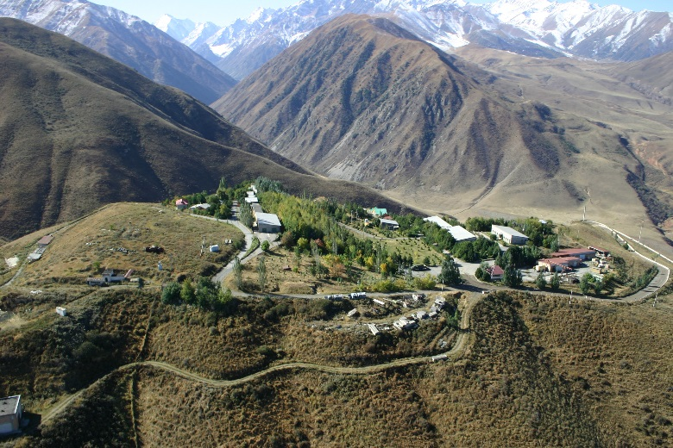
MATERIALS PUBLICATION
The participants may submit to the Organizing Committee:
- Abstract (thesis) of the Report (no more than 1 page);
- Extend abstract (no more than 4 pages).

All materials should be submitted as attached files
by e-mail: ns_ran@mail.ru
Abstracts should be submitted in Russian or English
till 1st May 2018. The Book of Abstracts will be issued
to the opening day of the Conference.
Organizing Committee does not edit the abstracts!

Organizing Committee reserves the right of oral reports and abstracts selection for publication!

REQUIREMENTS to ABSTRACTS
Structure
- Paragraph 1 (on top) – title of the abstract.
- Paragraph 2 author (s) initials, surname (s), phone, fax, Е-mail
- Paragraph full name of organization, city, country
- Paragraph 4 text of abstract.
Paragraph 5 numbered reference list (references in the text should be in the form [1,2 - ].
Format
- Text edit – Microsoft Word
- Page format – А4
- Margins: top – 2 cm, bottom – 2 cm,
right – 2 сm, left – 2 сm
- Font – Times New Roman
- Type size – 12
- Single spacing
- Tabulation – 1,25 см

CONFERENCE SCHEDULE
Deadline for application acceptance and texts of abstracts submission
1 May 2018
Sending out of second secular with tentative program
1 June 2018
Working days of Conference
3 – 7 July 2018

CONTACTS:
Academic Secretary of RS RAS
Olga Zabibyakova
E-mail: zabinyakova@gdirc.ru
ns_ran@mail.ru
Tel.: 996 (312) 61-31-40

Information on the Conference
will be published on the RS RAS website www.gdirc.ru
and sent out to persons interested in participation in the conference.

REGISTRATION FORM
International Jubilee Conference INFLUENCE OF EXTERNAL FIELDS
ON SEISMIC REGIME AND MONITORING OF THEIR MANIFESTATION

Bishkek city, Kyrgyz Republic
3 - 7 of July 2018.

Surname, Name
Academic degree, title
Name of organization
Position
Tel. number
E-mail
Title of scientific report
Information about each author: Surname, name., place of work or study (full name of organization , department: faculty, department, laboratory), postal address of organization, tel., e-mail | 1.
 | 2.
 | 3.
Form of participation
(oral report,
Poster presentation,
listener)
Number and title of RFBR project
(if your report is based on results obtained within research with financial support from Russian Foundation for Basic Research
Travel details
Hotel accommodation

Please do not hesitate to apply to
Academic secretary of RS RAS Zabinyakova Olga
on all questions connected with execution of reports
Тел.: + 996 (312) 61-31-40
+ 996 (312) 61-14-59
E-mail: zabinyakova@gdirc.ru
ns_ran@mail.ru; tua@gdirc.ru

